**INSTRUCTION GUIDE FOR SIGNATURE**

1. **Click on File tab in Outlook**

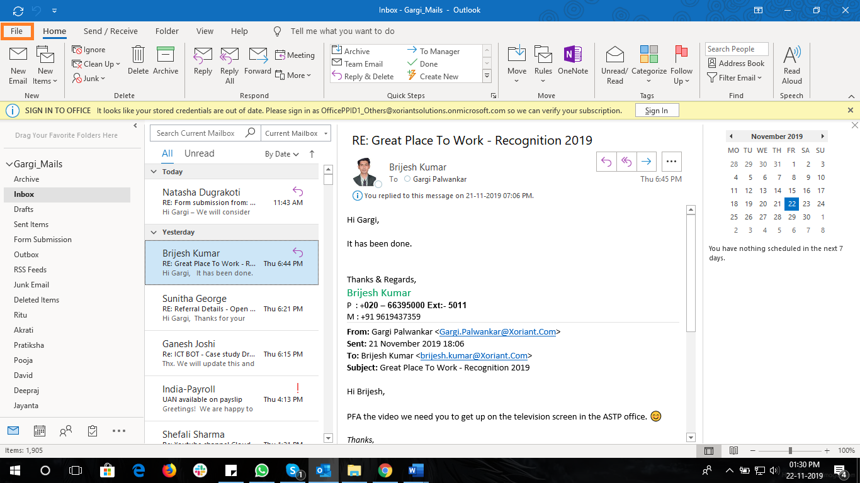

1. **Click on Options** 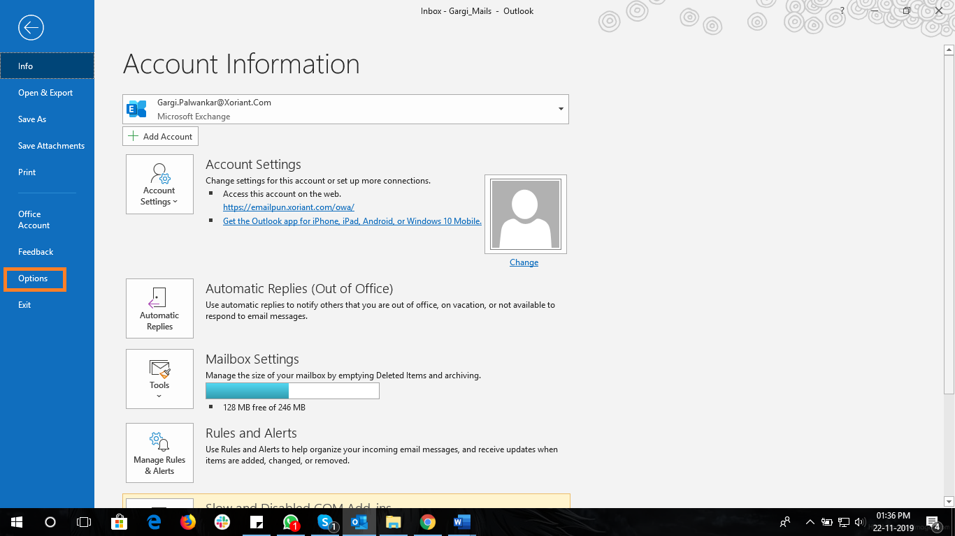
2. **Click on Mail**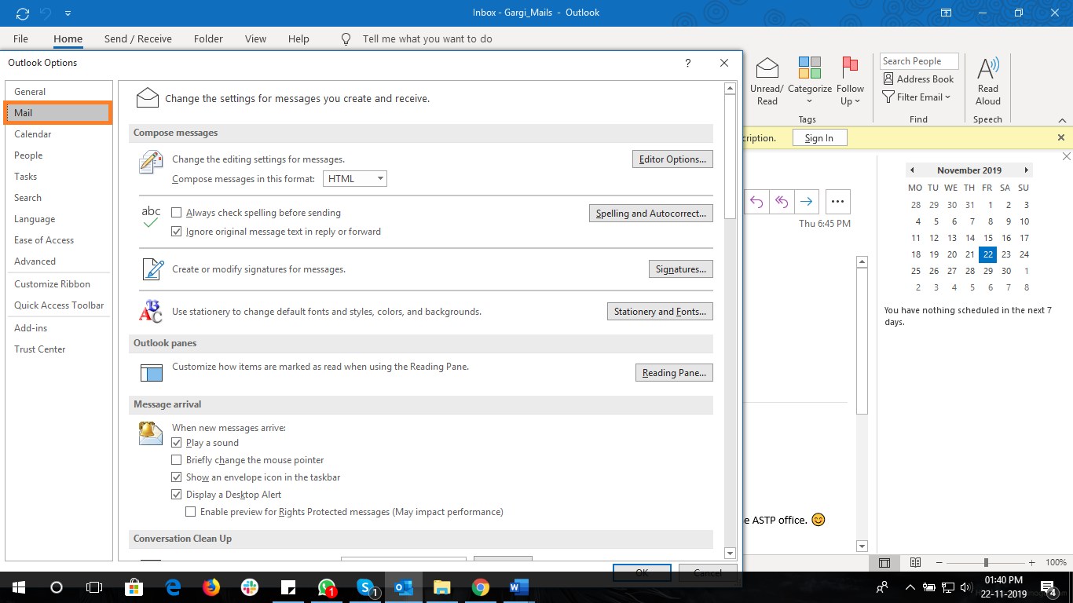
3. **Then click on Signatures**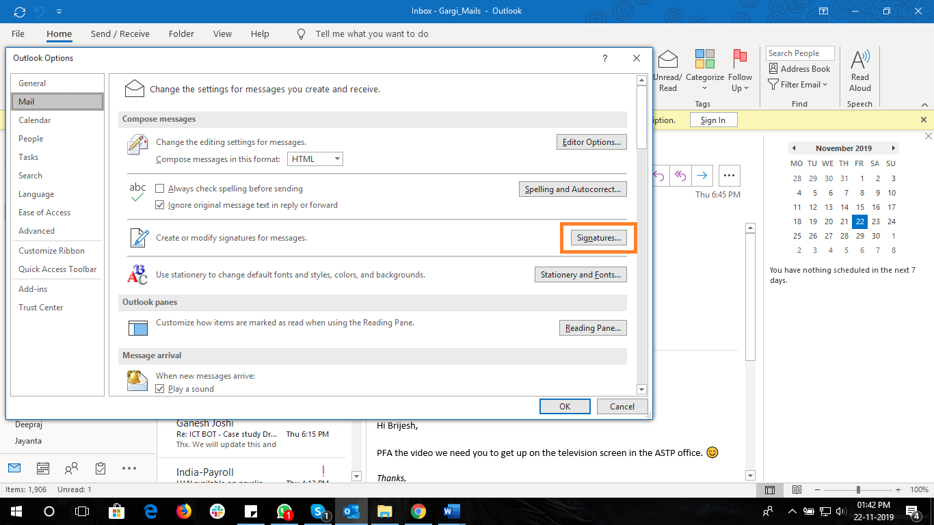
4. **Click on New and write the name of the signature as e.g. Signature**

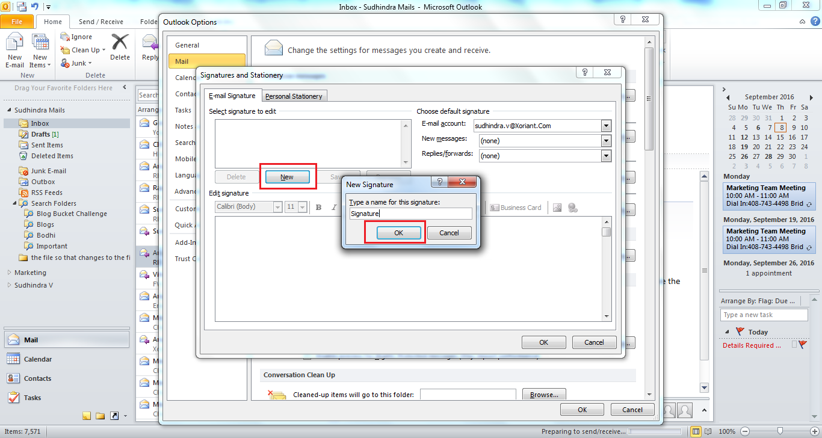

1. 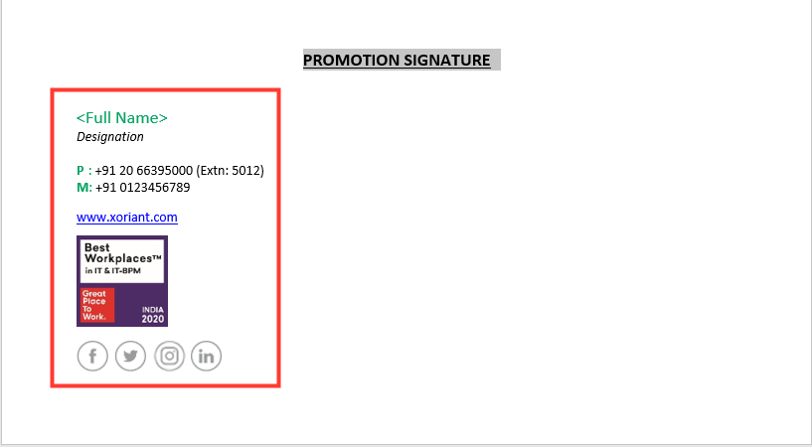**Copy the content under PROMOTION SIGNATURE sent to you in the word document. This needs to be used for all external or client-facing mails.**
2. **Paste the content and edit with your details & save the signature. Under the default signature select the name of the signature you are working on for the new message.**

**(Ex: Signature in this case) then CLICK ‘OK’.**

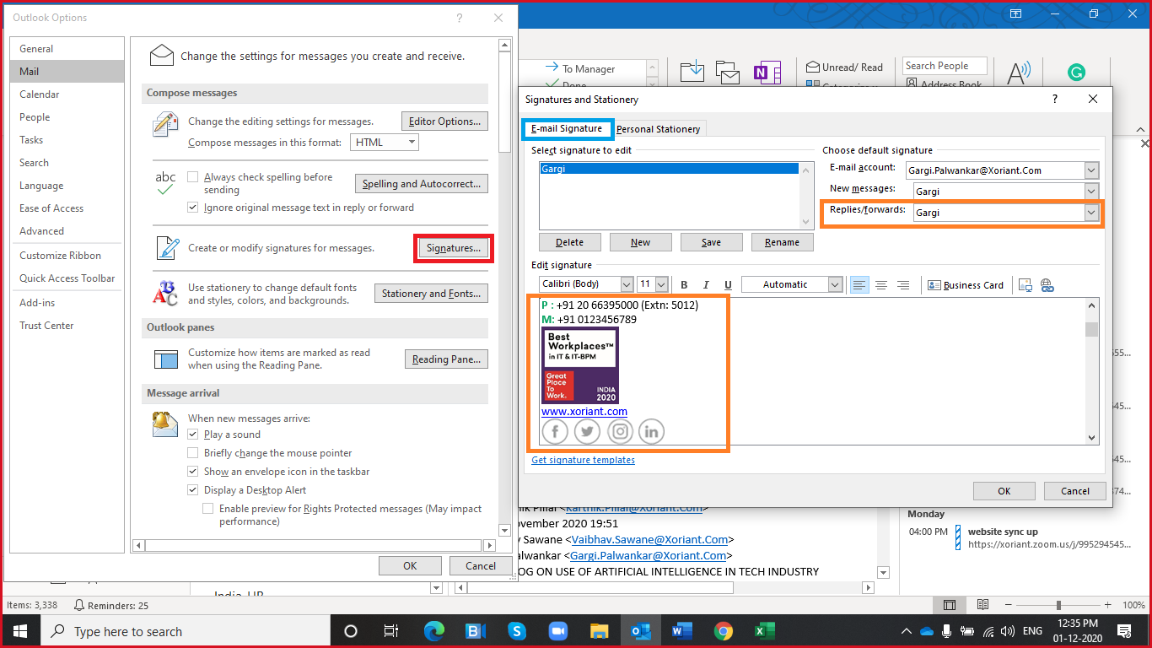

1. 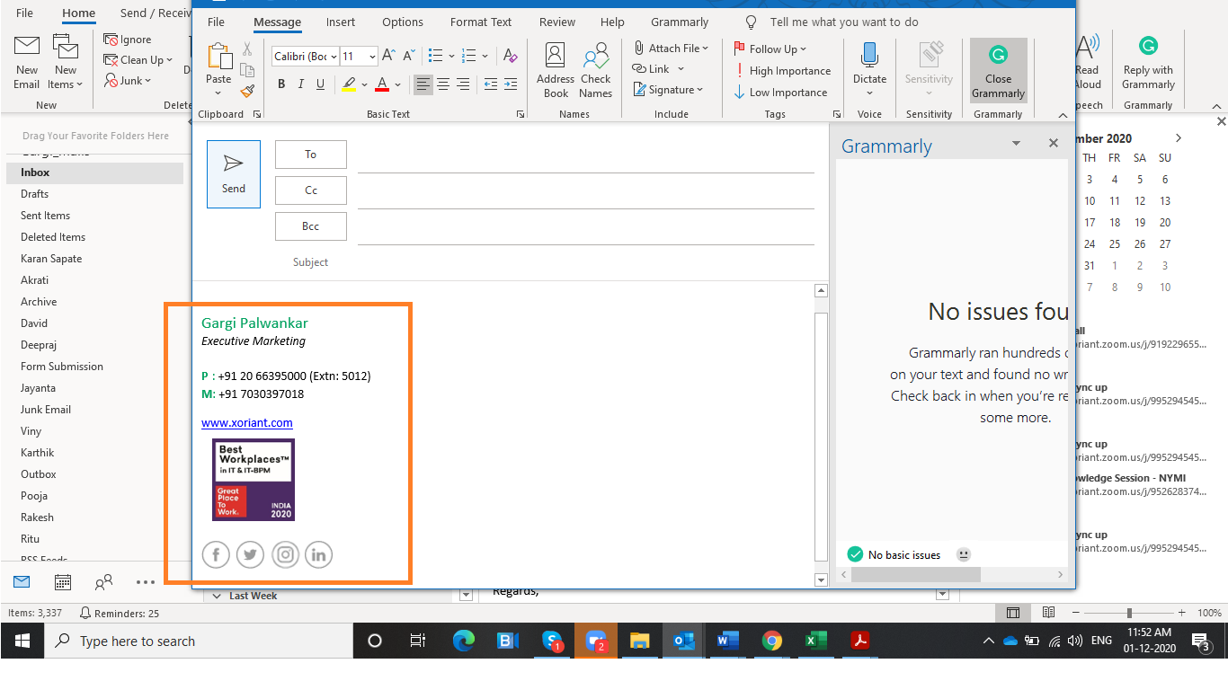**Now click on New email and check if your signature is incorporated.**

**Note:** Before you copy-paste the new signature in your Outlook’s ‘Signature’ section, please edit: **Name, Designation, Phone, and Mobile Number**